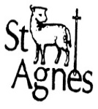
St Agnes CE Primary School
Reception Triangles Newsletter
Summer 2 2018
Staff: Miss Hewat, Mrs Smith,  Mr Schjelderup & Mrs Panteli | 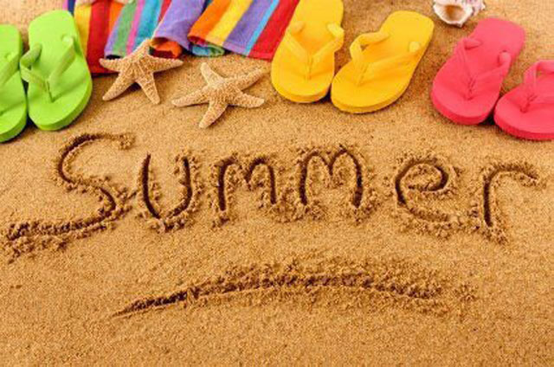
This Term
This half term our topic is
‘Travel and Journeys’
We will be using our skills, knowledge and exploring to find out the answer to our big question:
‘Where would you like to go?’
In Phonics, we will continue putting the letters and sounds we’ve learnt together to make simple words, and put those words together to write simple sentences. We’ll be trying to use finger spaces to separate the words and full stops to separate sentences.
In Reading, we’re going to be reading a variety of books, including some stories and information books.
In Maths, we’re going to continue developing our number skills and apply those skills to add and subtract and solve problems.
Don’t Forget…  If the weather is hot and sunny, put sun cream on your child before he/she comes to school. A sunhat, sunglasses and a bottle of water will help in hot weather too.  Look at the website for regular class updates:  www.st-agnes.manchester.sch.uk | Important Dates  Staff training day  Monday 18th June 2018  End of the school year  Friday 20th July 2018
Special Events/Activities/News

Soccer Aid Friday 8th June 2018
Please wear sporty clothes.

Coming soon –
Graduation Assembly
Reception class Disco

Reminders

Book bags need to be brought into school every day, these can be bought from the School office.

Please keep toys at home, we have lots to play with at school and they get lost or broken around the classroom.

