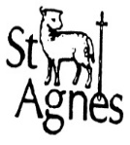
St Agnes CE Primary School
Year One Newsletter
Autumn 1 2019
Staff  Year 1T:  Class teacher - Mrs Milner  Teaching Assistant – Miss Ahmed  Year 1C:  Part-time Class teacher – Mrs Smith  Part-time Class teacher – Mrs Heap  Teaching Assistant – Mrs Pantelli  Both classes:  HLTA – Mr Johnson |   Love to learn  Learn to do well  Live well together.
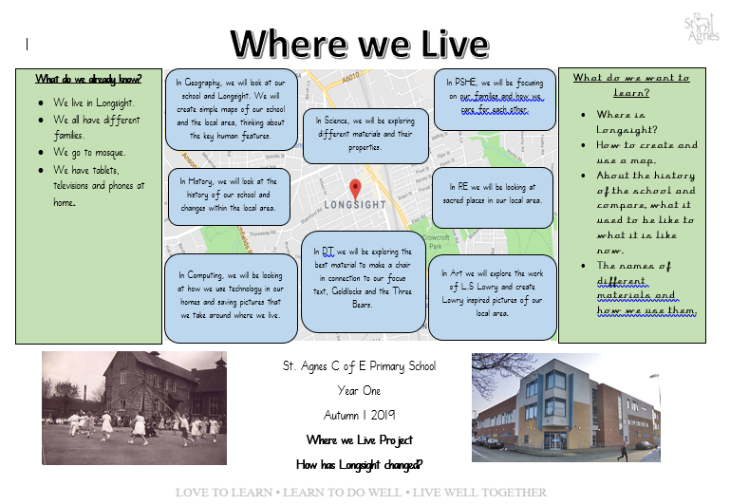
Don’t Forget…
Homework will be sent out every Friday to be returned on the following Thursday.
PE will be every Friday. Please send your child with their PE kit with their name on and in a drawstring PE bag. Their kit will be sent home every half term.
Reading books will be changed once a week. Please send them in everyday, in a green book bag. Please listen to your child read every day and write a comment in the reading record book.
Look at the website for regular class updates
– www.st-agnes.manchester.sch.uk

Important Dates and Events
We will be holding a welcome morning for Year One parents to meet the Year One staff and see their child’s classroom – date to follow.
Science Week – Week beginning Monday 16th September 2019
School Photographs – Wednesday 25th September 2019
International Peace Day - Friday 20th September 2018
Harvest – Monday 14th October 2019
Pens Down Day – Wednesday 2nd October 2019
Reminders
Remember to send your child in with a coat.
Please can all clothes be labelled with your child’s name.
As milk is no longer provided to all children, your child can bring a water bottle to school.

