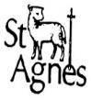**Knowledge Organiser Reception**

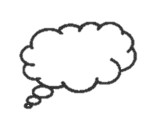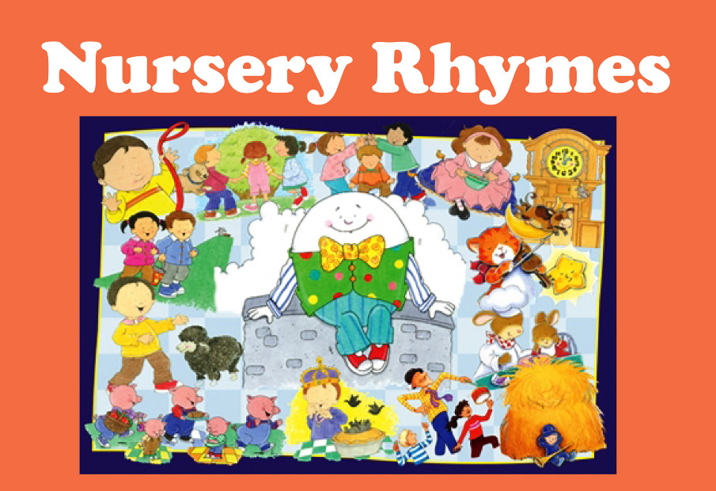

Nursery Rhymes

1 is 1 and 2 is 2, I’m a spaceman…

Head shoulders knees and toes

10 green bottles

Hickory Dickory dock

1, 2 buckle my shoes

Old MacDonald had a farm

Teddy bear, Teddy bear

I would like to know

more about…

* Other parts of the body and what the parts are called – “Heads, shoulders, Knees and Toes”
* Which animals live on a farm – “Old MacDonald”
* Times of the day – “Hickory Dickory Dock”
* Things in space - “1 is 1 and 2 is 2 is, 1’m a spaceman”

Quick Quiz

1. Can you count backwards from 10?
2. Can you name the different parts of your body?
3. Can you continue a rhyming string? Eg. Dog, log…
4. Can you perform your favourite nursery rhyme?
5. Can you name animals that would not live on old MacDonalds farm?
6. Can you change a rhyme to make your own song?