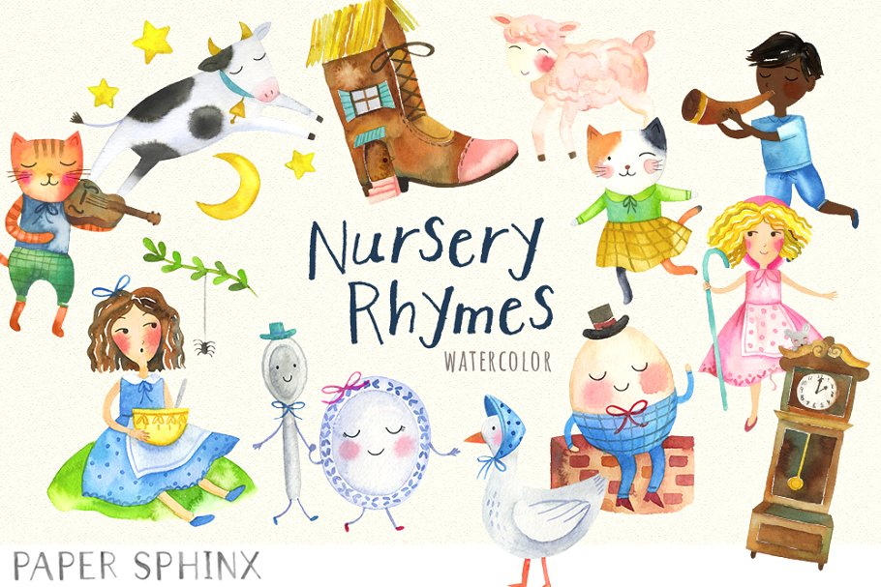

Nursery Rhymes

Five little ducks

5 Cheeky monkeys

Baa baa black sheep

1,2,3,4,5

Incey Wincey

5 little men in a flying saucer

Wheels on the bus

Quick Quiz

1. Can you count back from 5?
2. Can you do the actions for the rhyme “Wheels on the Bus”? Wipers, Bell, Doors, Lights, horn, wheels, Mummies.
3. What did Incey Wincey Spider climb up?
4. Can you think of something that rhymes with cat?
5. How does mummy duck feel?
6. Which animal snaps at the cheeky monkeys?

I would like to

know more

about…

What do ducks eat?

Where do monkeys live?

What noises do animals make?

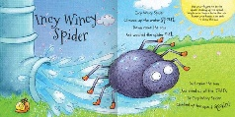

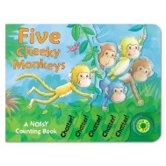

Key vocabulary:

* Rhyme
* Listening
* Tone
* Volume

**Nursery Autumn 1**

**Topic: Nursery Rhymes**



**Understanding the World**

**People and Communities**

**22-36 Months**

• Has a sense of own immediate family and relations.

**The World**

**16-26 Months**

• Explores objects by linking together different approaches: shaking, hitting, looking, feeling, tasting, mouthing, pulling, turning and poking.

• Remembers where objects belong.

• Matches parts of objects that fit together, e.g. puts lid on teapot.

**Technology**

**16-26 Months**

• Anticipates repeated sounds, sights and actions, e.g. when an adult demonstrates an action toy several times.

• Shows interest in toys with buttons, flaps and simple mechanisms and beginning to learn to operate them

**Personal Social and Emotional Development**

**Making relationship**

**22-36 Months**

• Interested in others’ play and starting to join in.

• Seeks out others to share experiences.

• Shows affection and concern for people who are special to them.

**Self-Confidence and Self Awareness**

**22-36 Months**

• Separates from main carer with support and encouragement from a familiar adult.

• Expresses own preferences and interests.

**30-50 Months**

• Can select and use activities and resources with help.

**Managing eeelings and behaviour**

**22-36 Months**

• Seeks comfort from familiar adults when needed.

• Can express their own feelings such as sad, happy, cross, scared, worried.

• Responds to the feelings and wishes of others.

• Aware that some actions can hurt or harm others



**Exploring and using media and materials**

**16-26 Months**

• Begins to move to music, listen to or join in rhymes or songs.

• Notices and is interested in the effects of making movements which leave marks.

**22-36 Months**

• Joins in singing favourite songs.

**30-50 Months**

• Enjoys joining in with dancing and ring games.

• Sings a few familiar songs.

• Beginning to move rhythmically.

• Imitates movement in response to music.

• Taps out simple repeated rhythms.

**BI**

**16-26 Months**

• Expresses self through physical action and sound.

• Pretends that one object represents another, especially when objects have characteristics in common

**30-50 Months**

• Creates movement in response to music.

Progression in

Skills

**Suggested stories:**

Incy Wincy Spider

Ring a Ring of Roses

Hickory Dickory Dock

‘100 Best Loved Nursery Rhymes’ by [Belinda Gallagher](https://www.amazon.co.uk/s/ref=dp_byline_sr_book_1?ie=UTF8&field-author=Belinda+Gallagher&search-alias=books-uk&text=Belinda+Gallagher&sort=relevancerank)

‘I'm Starting Nursery: A Pirate Pete Book’ by Amanda Li

‘You Choose’ by Pippa Goodhart & Nick Sharratt



