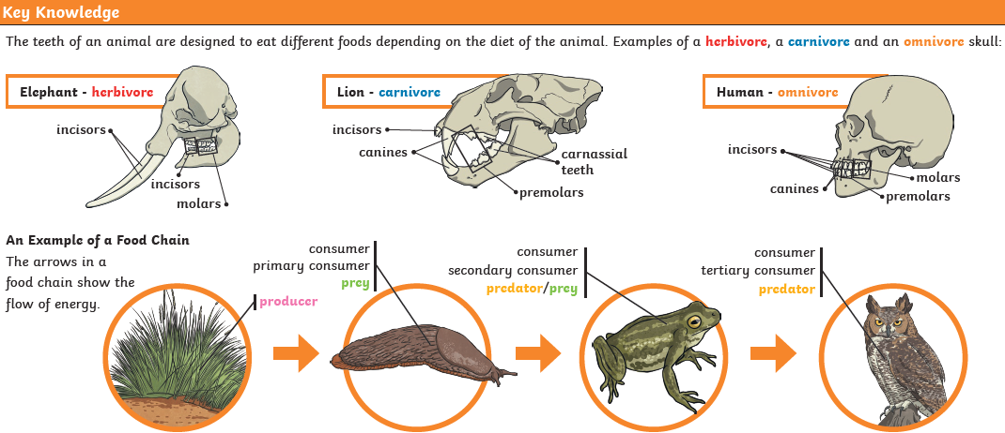

**Key Knowledge- Digestion**

**How do our bodies break down food?**

Our body needs food to provide it with energy, vitamins, and minerals. However, in order use food, we must first break it down into substances that the various organs and cells in our body can use. This is the job of our digestive system. The digestive system acts in stages to digest our food. Each stage is important and prepares the food for the next stage. The entire length of our digestive system is around 20 to 30 feet! Here are the major stages of the digestive system:

1. Chewing - When you chew your food it breaks up big pieces into little pieces that are easier to digest and swallow by using enzymes in your saliva.

2. Swallowing - Our tongue helps to push food into the back of our throat, then special muscles force it down the oesophagus until it gets to the stomach. The epiglottis blocks our windpipe and stops us from choking.

3. Stomach - More enzymes break down the food into things our body needs. The stomach kills a lot of bad bacteria as well, so we don't get sick.

4. Small Intestine – Works to continue to break down our food and then the food is absorbed from the intestine into our body through the blood.

5. Large Intestine - Any food that the body doesn't need or can't use is sent to the large intestine and later leaves the body as waste.

**Key Vocabulary**

