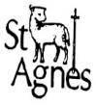**Knowledge Organiser Reception**

**Animals**

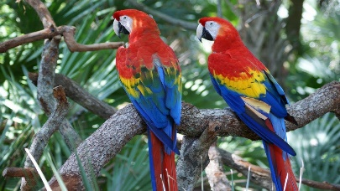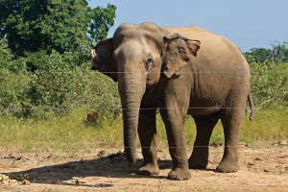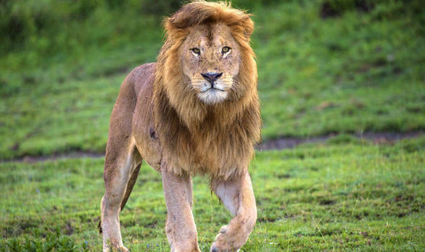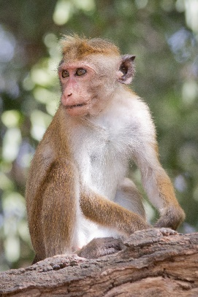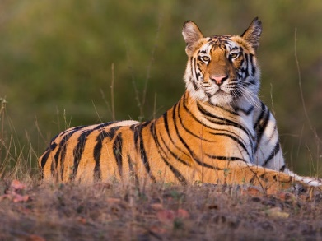

**Quick Quiz**

1. **Can you name some jungle animals?**
2. **Which animals would you keep as a pet?**
3. **Where are the different places animals could live?**
4. **How is an animal’s home different to your home?**
5. **Make a list of the animals you know.**

**Talk for Writing text:**

**Walking Through the Jungle**

**Must reads:**

* **Owl Babies**
* **Monkey Puzzle**
* **The Tiger That Came to Tea**
* **Whose baby?**
* **Who’s in the shed?**
* **The Snail and the Whale**
* **Dear Zoo**

**I would like to know more about**

* **Snake**
* **Tiger**
* **Elephant**
* **Lion**
* **Monkey**
* **Different habitats**

