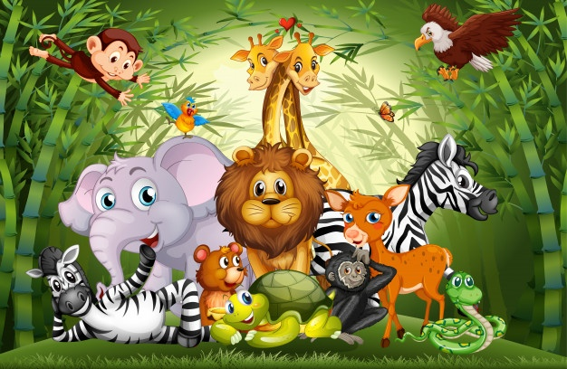`

Quick Quiz

1. Can I talk about where different animals live?
2. Can I make different animal sounds?
3. Can I match the mummy animal to the correct baby animal?
4. Can I name different baby animals?
5. Can I describe what different animals look like?

6. Can I name the animals found at a zoo and a farm?

Animals

Talk for Writing Focus

-Dear Zoo (fiction)

-Farm Animals (non-fiction)

I would like to know more

about…

-Where do animals live?

-Where can you see animals?

-Who do animals live with?

-Are all animals the same?

**Nursery Spring 1**

**Topic: Animals**

Key Vocabulary:

* Animal
* Parents
* Habitat
* Endager
* Zoo
* Farm
* Young
* Mammals



**Understanding the World**

**People and Communities**

**30-50 Months**

• Remembers and talks about significant events in their own experience.

• Recognises and describes special times or events for family or friends.

**The World**

**30-50 Months**

• Can talk about some of the things they have observed such as plants, animals, natural and found objects.

**Technology**

**22-36 Months**

• Operates mechanical toys, e.g. turns the knob on a wind-up toy or pulls back on a friction car.

**30-50 Months**

• Shows skill in making toys work by pressing parts or lifting flaps to achieve effects such as sound, movements or new images.

**Personal Social and Emotional Development**

**Making Relationships**

**30-50 Months**

• Initiates play, offering cues to peers to join them

• Demonstrates friendly behaviour, initiating conversations and

forming good relationships with peers and familiar adults.

**SC, SA**

**30-50 Months**

• Confident to talk to other children when playing, and will communicate freely about own home and community.

**MFB**

**30-50 Months**

• Aware of own feelings, and knows that some actions and words can hurt others’ feelings.

• Can usually adapt behaviour to different events, social situations and changes in routine.

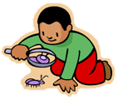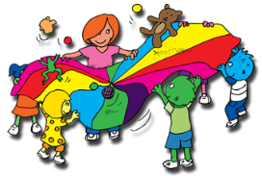

**Exploring and using media and materials**

**EMM**

**30-50 Months**

• Understands that they can use lines to enclose a space, and

then begin to use these shapes to represent objects.

• Beginning to be interested in and describe the texture of things

**BI**

**22-36 Months**

• Beginning to make-believe by pretending.

**30-50 Months**

• Developing preferences for forms of expression.

• Engages in imaginative role-play based on own first-hand experiences.

• Builds stories around toys, e.g. farm animals needing rescue from an armchair ‘cliff’.

• Uses available resources to create props to support role-play.

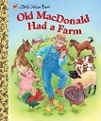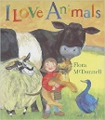

Progression in

Skills

**Suggested stories:**

I Love Animals Old McDondald had a farm

Where’s Spot?

Monkey Puzzle

Driving My Tractor

