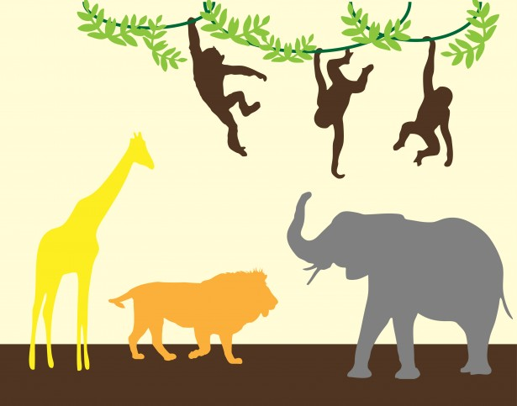

Personal Social and Emotional Development (PSE)

In PSE, we will be focusing on adjusting our behaviour to different situations and confidently trying new activities.

Expressive Arts and Design (EAD)

In EAD, we will be focusing on role playing our own ideas and stories and working alongside children who are engaged in the same theme.

Understanding the World (UW)

In UW, we will be focusing on our own environment, how they are different and may vary and the different animals living within the environment.

**Topic Web**

Physical Development (PD)

In PD, we will be focusing on moving in different ways and becoming more aware of the space around us.

Communication and Language (CL)

In CL, we will be focusing on responding to ideas expressed by others and following stories without pictures or props.

Literacy

In Literacy, we will be focusing on mapping our own story and identifying what a sentence is. Our Talk for Writing (T4W) will be Walking Through the Jungle.

Maths

In Maths, we will be focusing on adding and subtracting numbers and creating number sentences to support our learning.