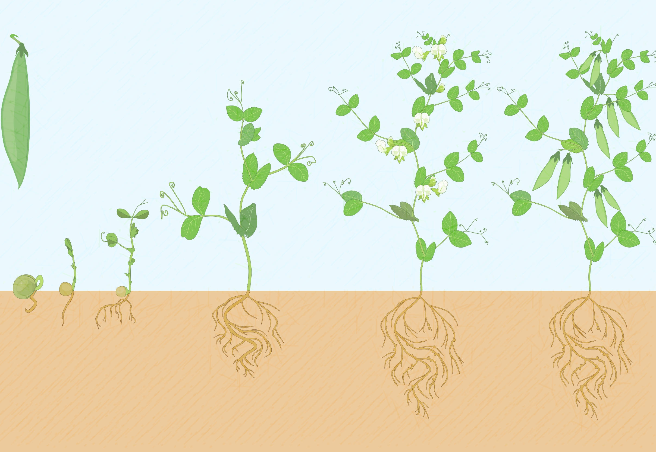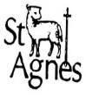**Knowledge Organiser: Reception**

**Growth and Change**

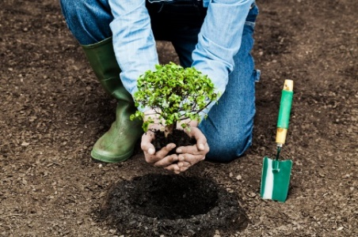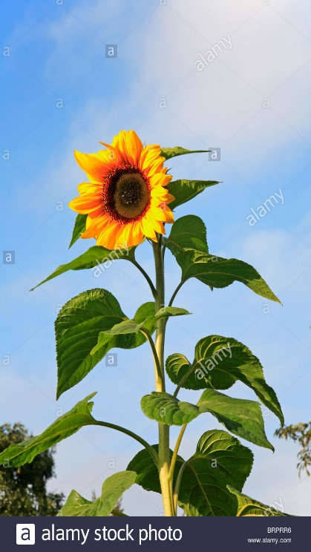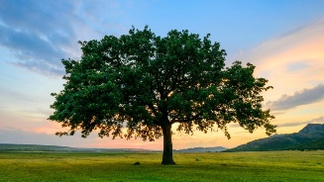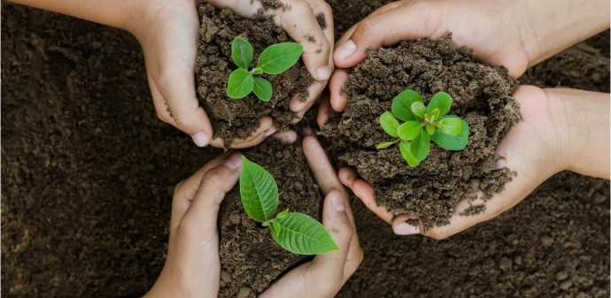

**Topic Songs:**

* **Dancing in the sun**
* **Head, shoulders, knees and toes**
* **I’m a little bean**
* **Little seed**

**Talk for Writing text:**

**Supertato**

**Must reads:**

* **Oliver’s Vegetables**
* **Oliver’s Fruit Salad**
* **Window**
* **Handa’s Surprise**
* **Supertato Sequels**
* **Jesse’s Flower**
* **The Tiny Seed**
* **Christopher’s Caterpillars**

**Quick Quiz**

1. **What do plants need to help them grow?**
2. **How can we look after plants?**
3. **What are living things?**
4. **How tall can sunflowers grow?**
5. **What flowers can I make a list of/**
6. **How do plants help our lives?**
7. **What things can we grow by planting?**
8. **How do plants change overtime?**

**I would like to know more about:**

* **The bean cycle.**
* **How plants change over time.**
* **How to look after plants.**
* **Things that grow.**
* **Different types of living things.**