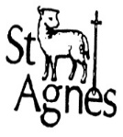
St Agnes CE Primary School
Reception Triangles Newsletter
Spring 2 2020
Staff:  Mrs Chowdhury & Miss Carroll | 
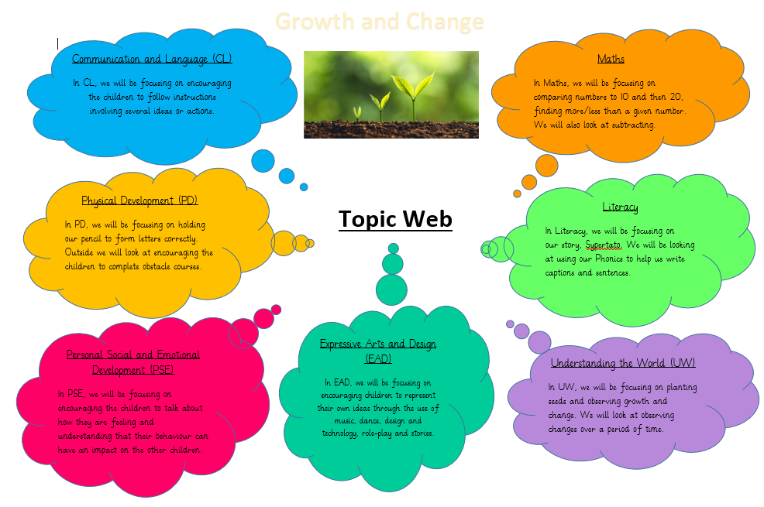

See previous post for full Topic Web
Don’t Forget…  *Your child needs a coat every day, whatever the weather.  *Please write your child’s name in their coat, gloves, scarf, hat etc.  *Book bags need to be brought into school every day, these can be bought from the School office. | Important Dates  Library Visits: Week Beginning 24th February 2020  Thursday 5th March – World Book Day (Please bring in your child’s favourite book or object/costume from their favourite book).  The Book Fair will be in school from the 3rd to the 5th March, in the main hall from 8.45am and 3.15pm.  Friday 3rd April – last day of school before Easter holiday.
Special Events/Activities/News

Feel free to dress us as a character from your favourite book on World Book Day!
‘Box Day’
Friday 20th March 2020
Join your child for a fun creative activity session. Details to follow!
Reminders
No Jewellery to be worn in school.
Please keep toys at home, they might get lost or broken around the classroom.

