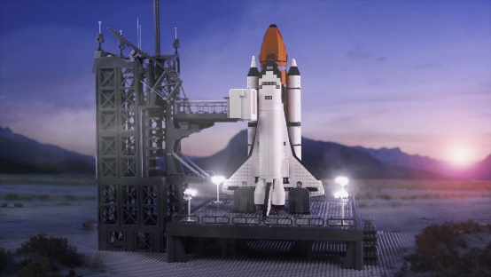

Maths

In Maths, we will be focusing on doubling and halving, counting on and back, multiplication and division, odd and even numbers, weight and capacity.

Personal Social and Emotional Development (PSE)

In PSE, we will be focusing on adjusting our behviours and taking changes of routine in stride.

Understanding the World (UW)

In UW, we will be focusing on making observations about plants and animals and explain why some things occur, and talk about changes.

Physical Development (PD)

In PD, we will be focusing improving our pencil grip, to ensure our letters are correctly formed.

Communication and Language (CL)

In CL, we will be focusing on developing our own narratives and explanations by connecting ideas or events.

Literacy

In Literacy, we will be focusing on the tricky words: my, you, they, all, are, her, said, like, some, come, have, were, there, little, one, do. Our book this half term is How to Catch a Star.

Expressive Arts and Design (EAD)

In EAD, we will be focusing on exploring a variety of materials, tools and techniques, experimenting with colour, design, texture, form and function.

**Topic Web**