Q1.

Here is a rectangle.

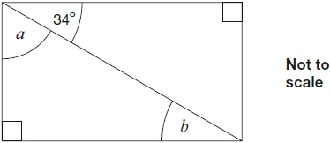
Calculate the size of angles a and b.
Do not measure the angles.
1 mark
1 mark
Q2.
This is a rectangle with its two diagonals.
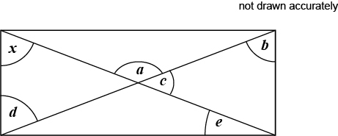
Angle x = 58°
Circle the two angles that are the same size as angle x
a b c d e
1 mark
Q3.

Anna has four different triangles.
Complete the table to show the size of the angles in each triangle.

 | Type of triangle | Angle 1 | Angle 2 | Angle 3
 | Isosceles | 90°
 | Right-angled | 80°
 | Isosceles | 70°
 | Isosceles | 70°
2 marks

