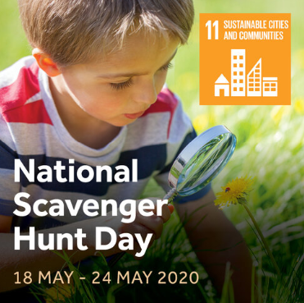
Week 3
National Scavenger Hunt Week is a time to enjoy the fun of a scavenger hunt. It’s time to look down, and look closely at the fascinating world around us. Hunt for habitats and living things in your spaces.

Share your questions about birds and wildlife:
Twitter |  |  |  |  | Facebook
@greatscishare | #greatscishare |  |  |  | @greatscishare4schools
@year6luntsheath | #sciencefromhome |  |  |  | #greatscishare |  |  | #sciencefromhome
Key Questions
Where can I find wildflowers? |  |  |  | How many shades of green can I see near me?
Which insects are in this habitat? |  |  |  | Click here to make your own questions using our free question hand!
Inspirational Things To Do:
Sir David Attenborough’s mind-blowing variety of life on Earth video. |  | Live lesson @DrChips_  20th May  ENGINEERING HABITAT CHALLENGE  https://www.youtube.com/watch?v=V5PVsZPOkug&feature=youtu.be |  |  |  |  | #askaquestion  Dr Eleanor Raffan  https://www.greatscienceshare.org/journal/2019/5/16/askaquestion-dr-eleanor-raffan
Click on the links below to find extra resources for your very own scavenger hunt!
Age 5-7 |  |  | Age 7-11 |  |  | Challenge
Go on a wildflower foray with other scientists. |  |  | Leaf it! Measure leaves and find links between trees and plants. |  |  | Floating Garden Challenge  Design and/or build a structure that will enable farmers to grow crops in an area that may become flooded.
Go on a spider safari around your home. |  |  | Complete a woodland plant survey.
Make an edible butterfly life cycle!
We can’t wait for you to share your science work with us.
#welovescience

